Shaik Sharifa Jahan

AP22110011103

1 (a) Write a program in assembly language to print single character on screen.

org 100h

mov AX, 0B800h

mov DS, AX

mov CL, 'A'

mov CH, 1101_1111b

mov BX, 00h

mov [BX], CX

ret

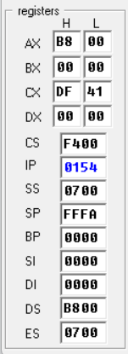

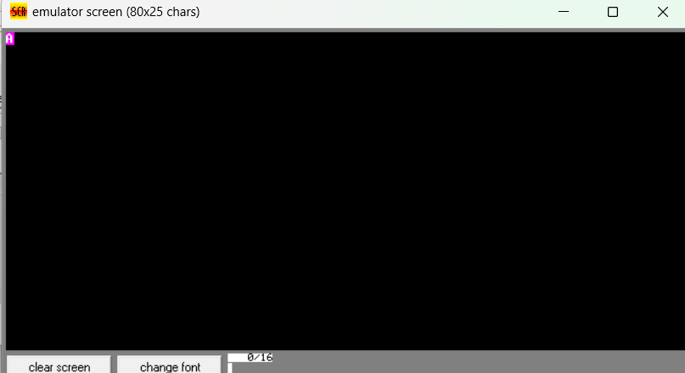

(b) Write an assembly language program to convert an upper-case letter to the corresponding lower-case letter.

org 100h

mov AX, 0B800h

mov DS, AX

mov CL, 'A'

add CL,32

mov CH, 1101_1111b

mov BX, 00h

mov [BX], CX

ret

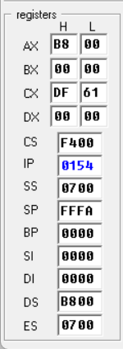

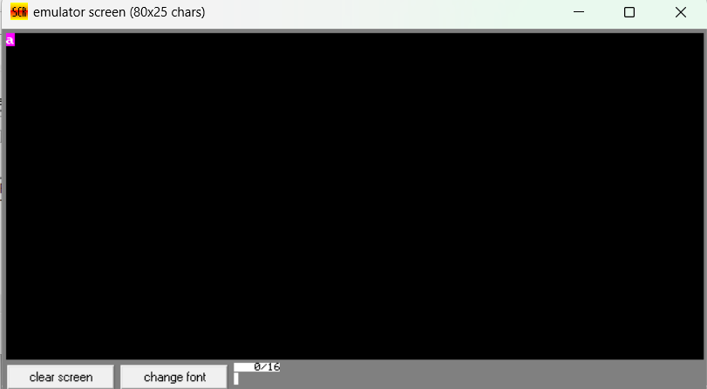

2. (a) Write a program in assembly language to print multiple characters on screen.

org 100h

mov AX, 0B800h

mov DS, AX

mov CL, 'A'

mov CH, 1101_1111b

mov BX, 0

mov [BX], CX

mov CL, 'B'

mov [BX + 2] , CX

mov CL, 'C'

mov [BX + 4] , CX

ret

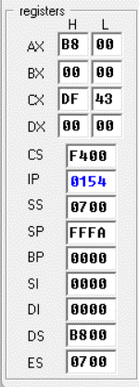

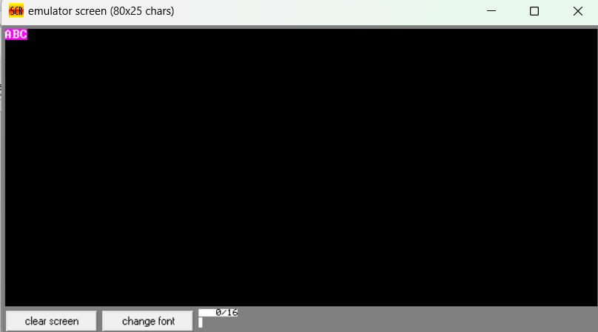

(b) Write an assembly language program to convert a lower-case letter to the corresponding upper-case letter.

org 100h

mov AX, 0B800h

mov DS, AX

mov CL, 'a'

sub CL,32

mov CH, 1101_1111b

mov BX, 00h

mov [BX], CX

ret

